Cleanup procedure for Policy and Procedures Documents

- Open document in Microsoft Word
- From the Main Menu select View->Normal
- Every section of the document requires the following settings updated to be viewable in the browser. The Right Indent should be set to 6 5/8” and all text set to Justifiy. The First Line Indent, and Left Indent need to be set to conform to the original documents style. The indents are found on the ruler section at the top of the document and just click and drag to the desired location.
- From the Main Menu select Edit->Select All to select all text, all selected text will turn black
- From the Main Menu select Format->Font
- Edit Font dialog box to look as follows:

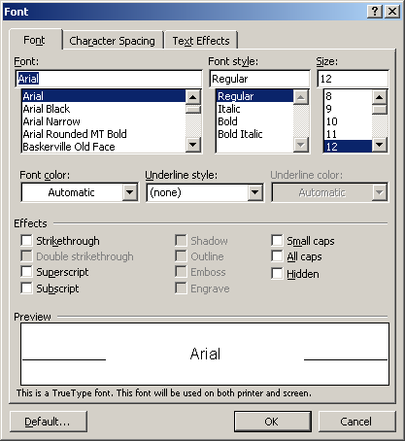
- Click OK
- Hold the left mouse button down and drag it over the title of the document to select the text.
- From the Main Menu select Format->Font
- Edit Font dialog box to look as follows:
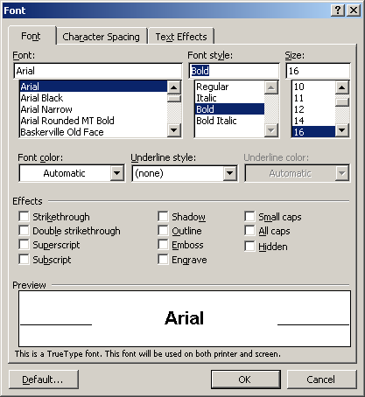

- Click OK and repeat steps 8-11 for all titles and headers in the document.
- From the main menu select File->Page Setup
- Edit Page Setup dialog box to look as follows: 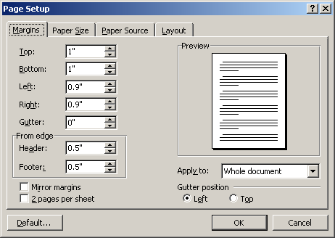
- Click OK
- Remove incorrect page numbers as follows:
- From the main menu select Edit->Find…
- Edit Find and Replace dialog box to search for page as follows: 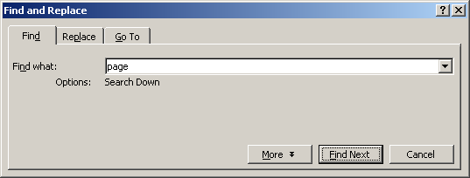
- Press the Find Next button
- Remove the page number and title lines that look similar to the following:
“Title I, Section 100 - page 1
Title I - Finances and Accounting”
To remove the text quickly press and drag the left mouse button over the text to be
deleted and then press the keyboard Delete key.
- Remove any remaining blank lines
- Repeat steps 16-18 until all page numbers are removed
- From the main menu select Format->Tabs…
- Edit Tabs dialog box to clear all Tabs by pressing the Clear All button.
- If you find a form in the document similar to the following:
Conference/Training Request and Report Form

Section I - Request
Department Name _________________________________ Index No. ____________

Employee Name and Title _________________________________________________

Conference/Training Title _______________________________________________

Host Organization* ______________________________________________________

Conference/Training Location ____________________________________________

Conference/Training Dates _______________________________________________

Your Date of Departure ______________ Your Date of Return ______________

Estimated Costs
4170 Registration Fee $ ________________
4166 Mileage $ ________________
4150 Airfare $ ________________
4162 Lodging Cost per night ________x____nights $ ________________
4164 Meals Per Diem Rate ________x____full days $ ________________
Partial Day Per Diem $ ________________
4168 Other (Describe) ______________________________ $ ________________
4168 Other (Describe) ______________________________ $ ________________

Purpose
Please describe the County purpose served by this conference/training.
What are the anticipated benefits? ______________________________________

_________________________________________________________________________

_________________________________________________________________________

_________________________________________________________________________

_________________________________________________________________________

Requester's Signature ______________________________ Date _______________

Approved By ________________________________________ Date _______________

Approved By ________________________________________ Date _______________

- You must place a hard page break before and after the form to facilitate printing the form on a single page as follows:
- Click on the line above the form and then select Insert->Break from the main menu
- Edit the Break dialog box to look as follows:

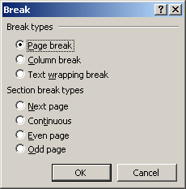

- Click on the line below the form and repeat steps 24-25.
- If you find information misaligned as follows:

IRS Meal & Incidental $30 $34 $38 $42
Rate (full day) per city
Breakfast (partial day) $5 $6 $7 $8
Lunch (partial day) $5 $6 $7 $8
Dinner (partial day) $14 $16 $18 $20
Incidentals $2 $2 $2 $2
(overnight only)

- It should be placed into a table, first put a – in front of the cell data as follows:
IRS Meal & Incidental - $30 - $34 - $38 - $42
Rate (full day) per city
Breakfast (partial day)- $5 - $6 - $7 - $8
Lunch (partial day) - $5 - $6 - $7 - $8
Dinner (partial day) - $14 - $16 - $18 - $20
Incidentals - $2 - $2 - $2 - $2
(overnight only)
- Select all the text by holding the left mouse button down and dragging it over all the text to be included in the table.
- From the main menu select Table->Convert->Text to Table
- On the Convert Text to Table dialog box change the Separate text at to Other: and make sure the – is the separator

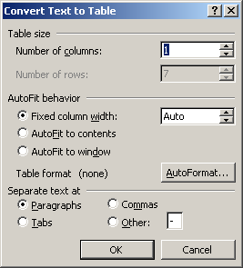

- Click OK and the data should be placed automatically in the correct sized table, there may be minor spacing corrections required.

IRS Meal & Incidental Rate (full day) per city | $30 | $34 | $38 | $42
Breakfast (partial day) | $5 | $6 | $7 | $8
Lunch (partial day) | $5 | $6 | $7 | $8
Dinner (partial day) | $14 | $16 | $18 | $20
Incidentals  overnight only) | $2 | $2 | $2 | $2

- The proportional spacing that was incorrectly converted to blanks needs to be removed, they are identified by Word with a green underline of the two words containing two or more spaces.
- Check for errors from the Main Menu select Tools->Spelling and Grammar for now click on Cancel and correct all green and red underlines.

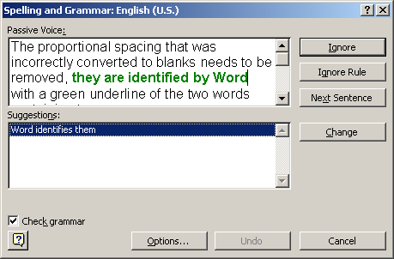
- Every section of the document requires the following settings updated to be viewable in the browser. The Right Indent should be set to 6 5/8” and all text set to Justifiy. The First Line Indent, Hanging Indent, and Left Indent need to be set to conform to the original documents style.

